## Topic Name:

The inter sectional disadvantage of socially excluded people

### Thesis:

**Introduction:**

Social exclusion is a well known term that frequently shows up in open approach and in discussions on friendly government assistance overall. There is additionally a lot of writing on friendly rejection. Nonetheless, the term isn't extremely clear for characterizing or conventionalizing for insightful purposes. At any rate, the idea of social prohibition was first carried out in France during the 1960s, where it was first utilized while discussing the poor, and during the 1970s the expression "prohibition social" was utilized while alluding to individuals with various types of hindrances, for example, being intellectually and physically crippled, manhandled kids, matured invalids, asocial people, substance abusers, and so forth.(Twenge et al., 2002) Over the course of the years from that point forward, studies on friendly rejection have involved even more classifications of people. Models incorporate denied, ignorant, long haul unemployed, poor, single guardians, social help beneficiaries, substance victimize and (Ward, 2009) occupants living in insufficient lodging and notorious areas. Along these lines, social rejection is associated with various affordable, social, political and social dimensions. Social avoidance is seen to some degree diversely in the public discussions in different nations, and more weight might be put on specific parts of prohibition depending on issues that are essential in a specific country.

**Forms of Social exclusion:**

The drivers of social rejection are perplexing and complex. The various types of rejection distinguished in the chart underneath outline this.

1. **Political Exclusion:**  
    The social and political prohibition of minorities and minimized bunches makes the potential for struggle. A minority is a gathering sharing an ethnic, social, strict as well as semantic personality that is unmistakable from that of most of the populace. One of the principle qualities of minorities is that they are for the most part in a non-prevailing position. The term minority may likewise allude to gatherings of the populace that are minimized by their political alliance, their sexual direction or even their actual limits.
2. **Cultural Exclusion:**

Diverse values, norms and ways of living are accepted and respected. Cultural Exclusion assigns what is going on of "huge populaces with troublesome admittance to the instructive assets important to enter conventional social circuits" who are, hence, prone to live on the edges of society.(Roldán, 2012) Taken in this sense, social avoidance can be likened to, or if nothing else at first contrasted with, "instructive rejection", which, thus, will in general build up different types of financial prohibition.

1. **Economic Exclusion:**

Economic avoidance implies that all shoppers approach protected, reasonable monetary items and administrations. Responsibility for exchange account is an initial move toward monetary prohibition. In hypotheses of rivalry in financial matters, an obstruction to passage, or a monetary boundary to section, is a decent expense that should be brought about by another participant, paying little heed to creation or deals exercises, into a market that occupants don't have or have not needed to cause.

## Research:

**Literature Sourcing and analysis:**

This audit draws on peer-looked into distributions and dim writing to survey the elements that add to the social avoidance of impaired individuals. In particular, data sets including Scopes, PsycINFO,(Obregón Sierra & González Fernández, 2019) Science Direct, and Google Scholar were looked through utilizing the accompanying hunt terms (frequently close by the term inability): social avoidance, media depiction, perspectives, availability, transport, instructive accomplishment, joblessness, pay, lodging, segregation, relationship breakdown, (Zheng et al., 2021) wrongdoing and apprehension about wrongdoing, hindrances to incorporation, magnificence, mainstream society, causes and social prohibition, values and social rejection, social avoidance of debilitated individuals, comprehensive society, and hypotheses of handicap.

**Concept of Social Exclusion:**

Social exclusion as a concept originated in the 1990s. It was based on the idea that citizens have rights to a certain basic standard of living and to participate in the core functions of society, such as employment, housing, health care and education. Social exclusion occurs when people suffer from disadvantage and are unable to secure these rights.(McKenna, 2006) As the use of the concept has grown, it has come to take on a more multi-dimensional aspect, extending well beyond poverty and material deprivation, to bring other spheres of well being, such as the ability to participate in the life of the community Sen has taken this even further in his framing of capabilities and functioning, which looks “at impoverished lives, not just at depleted wallets.” This view of poverty as capability deprivation has two key dimensions: the inability to interact freely with others, and restrictions on living opportunities, including employment and adequate housing This focus on both the distributional aspects (in terms of access to income and material resources) and the relational (in terms of social ties to family, friends, local community, state services and institutions.

**Consequences of Social Exclusion:**

The results of social avoidance feature the significance of making a comprehensive society. There are various results of social avoidance, and prohibition can mean various things for various individuals in various settings.(Hepp et al., 2007) The causes and outcomes of social prohibition are likewise firmly associated regularly bringing about people or gatherings encountering different types of burden. Key results noted in the writing connect with well being results, disparities and nature of life.The World Health Organization recognizes chronic weakness status and imbalances as one of the vital outcomes of social prohibition (WHO 2008). They propose that this disparity is driven by inconsistent admittance to assets, capacities and privileges.

## Analysis:

**Personal and Social relationship factor of exclusion:**

Relationships with others make up by far most of our lives. Family is the main group of friends a kid encounters, and family gives an establishment to any remaining social connections as a youngster develops. These first family connections are similarly as persuasive in the existences of handicapped individuals. For certain guardians, a youngster brought into the world with a handicap can frequently mean a relationship that starts in melancholy. Guardians regularly don't anticipate an incapacitated kid, and a youngster brought into the world with a handicap can frequently break guardians' assumptions for an 'ideal' kid This again mirrors the psychological models that drive our assumptions for the 'ideal'. Mental models likewise seem to impact social connections. Many sources highlight overprotection and shielding, or an absence of comprehension of individual capacities and requirements, by guardians, guardians, friends and authority figures that limit an open door for action and Individual Relationship Community Societal Expectations of ability Over-insurance and protecting Experience of tormenting Unfriendly environs Family assets Sense of disgrace area associating with others. These can emerge from vulnerability about ability, doubt of certain friends and family assets, which all confine cooperation.

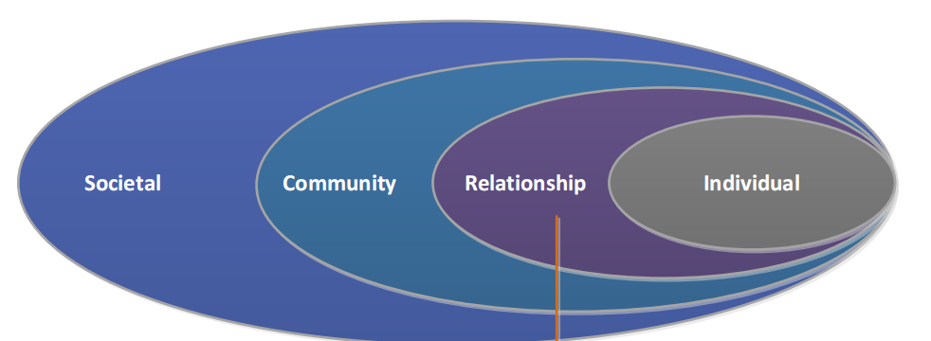

**Individual Health and Functioning:**

## Social exclusion through separation or disparagement can cause mental harm and damage well being through long haul pressure and nervousness. Chronic frailty can likewise prompt social prohibition. Social avoidance in the school climate is progressively being perceived as a type of social hostility or tormenting, in which a kid is presented to hurt through the control of their social connections and status. There are many type of social prohibition, for example, encounters being intentionally barred from a companion bunch, reports spread about them, ridiculing and being deliberately humiliated. Henceforth, social rejection opposes an absence of connectedness, cooperation, distance or disappointment from specific individuals inside the general public. An exclusion implies that an individual or element is prohibited from getting any cash from government or state medical care programs. Medical care rejections apply to any things or administrations a supplier might outfit, request, or recommend

## Conclusion:

Social exclusion is a perplexing idea that is characterized and examined in various ways. There are likewise various degrees of avoidance to comprehend including political, monetary, social and social. The writing presents numerous systems for getting social rejection, albeit the job of mental models, and underlying and financial variables are regularly refereed to (REFS). Mental models have been noted for their impact on our impression of the "ideal" and the acknowledgment of "others". These insights rise above across us at a worldwide, public, cultural, local area and person level, along these lines affecting our perspectives and ways of behaving. Mental models likewise impact the primary and financial drivers of rejection, which mirror the context oriented factors that impact avoidance or exclusionary rehearses. The key primary and financial drivers recognized in this survey were low pay, joblessness, training, transport, lodging, physical and psychological well-being, separation, relationship breakdown and elements of neighborhoods, as wrongdoing or the feeling of dread toward wrongdoing. This audit has likewise recognized the intricacy and supporting nature of these drivers, which can regularly prompt numerous layers of inconvenience or rejection for specific gatherings.

## References

Escera, I. (2011). El color escarlata en wikipedia. *Mosaic*, (88). https://doi.org/10.7238/m.n88.1129

Hepp, M., Siorpaes, K., & Bachlechner, D. (2007). Harvesting Wiki Consensus: Using Wikipedia Entries as Vocabulary for Knowledge Management. *IEEE Internet Computing*, *11*(5), 54-65. https://doi.org/10.1109/mic.2007.110

McKenna, B. (2006). Wikipedia just as ‘wiki’ as ever, says Wales. *Infosecurity Today*, *3*(6), 6. https://doi.org/10.1016/s1742-6847(06)70473-6

Munro, A. (2017). INTRA-HOUSEHOLD EXPERIMENTS: A SURVEY. *Journal Of Economic Surveys*, *32*(1), 134-175. https://doi.org/10.1111/joes.12196

Obregón Sierra, A., & González Fernández, N. (2019). Las universitarias en la Wikipedia en español. *Pixel-Bit, Revista De Medios Y Educación*, (54), 145-164. https://doi.org/10.12795/pixelbit.2019.i54.08

Renahy, E., Alvarado-Llano, B., Koh, M., & Quesnel-Vallée, A. (2012). Income and economic exclusion: do they measure the same concept?. *International Journal For Equity In Health*, *11*(1), 4. https://doi.org/10.1186/1475-9276-11-4

Roldán, K. (2012). SOCIAL EXCLUSION, SOCIAL COHESION: DEFINING NARRATIVES FOR DEVELOPMENT IN LATIN AMERICA. *Journal Of International Development*, *24*(6), 728-744. https://doi.org/10.1002/jid.2864

Twenge, J., Catanese, K., & Baumeister, R. (2002). Social exclusion causes self-defeating behavior. *Journal Of Personality And Social Psychology*, *83*(3), 606-615. https://doi.org/10.1037/0022-3514.83.3.606

Ward, N. (2009). Social Exclusion, Social Identity and Social Work: Analysing Social Exclusion from a Material Discursive Perspective. *Social Work Education*, *28*(3), 237-252. https://doi.org/10.1080/02615470802659332

Zheng, H., Tian, G., & Tan, D. (2021). FinTech, Financial Inclusion, and Household Portfolio Choice: Evidence from China Household Finance Survey. *SSRN Electronic Journal*. https://doi.org/10.2139/ssrn.3909717